|  |  |
| --- | --- |
| Semester | T.E. Semester VI – Computer Engineering |
| Subject | Cloud Computing |
| Subject Professor In-charge | Prof. Divya Nimbalkar |
| Assisting Teachers | Prof. Divya Nimbalkar |

|  |  |
| --- | --- |
| Student Name | Deep Salunkhe |
| Roll Number | 21102A0014 |
| TE Division | A |

**Title:**

Implementation of IaaS-Azur



**Implementation:**

**Scenario 1**

1. **Create a Ubuntu VM ( Any Ubuntu Machine) and connect using SSH**
2. **Install an ngnix web server on this machine**
3. **Display the default web page of ngnix server on public IP address of the machine**
4. **Change the default page content with your content to perform static website hosting**

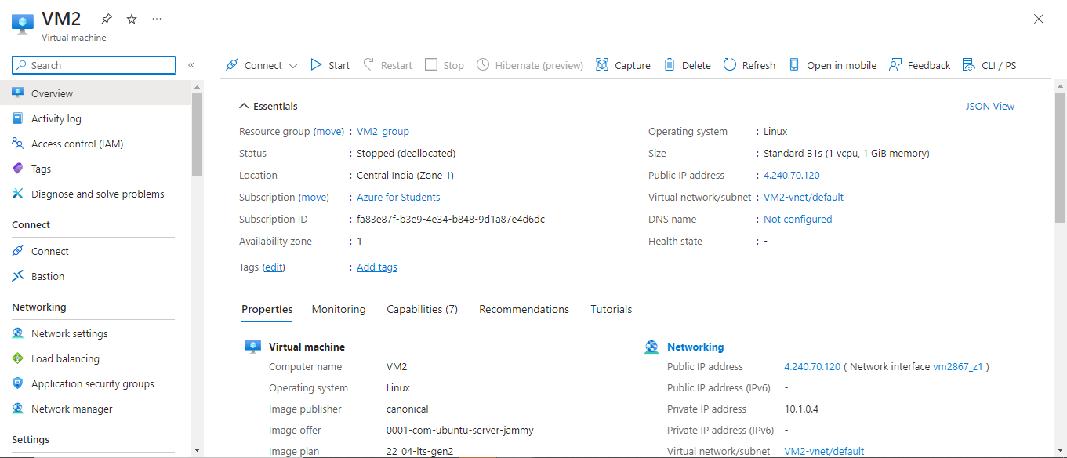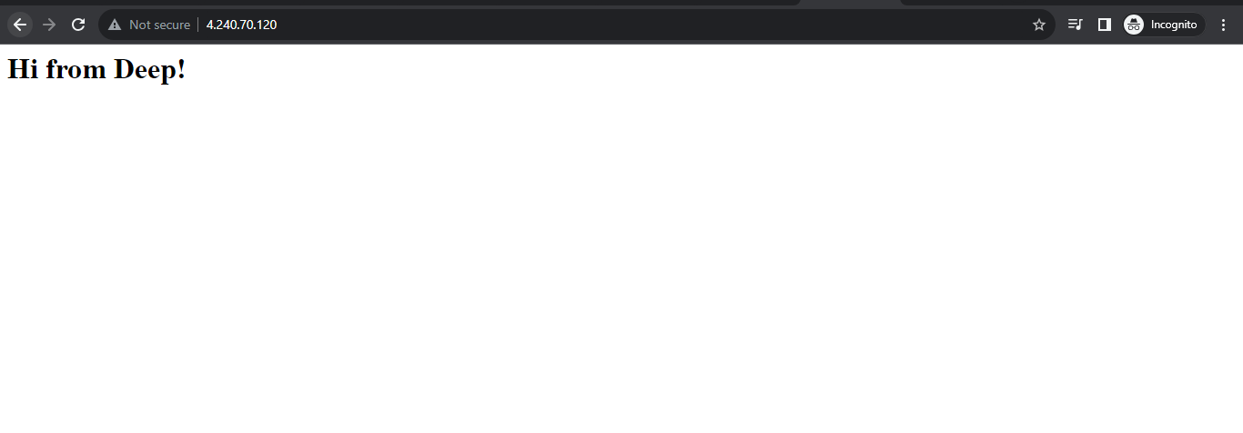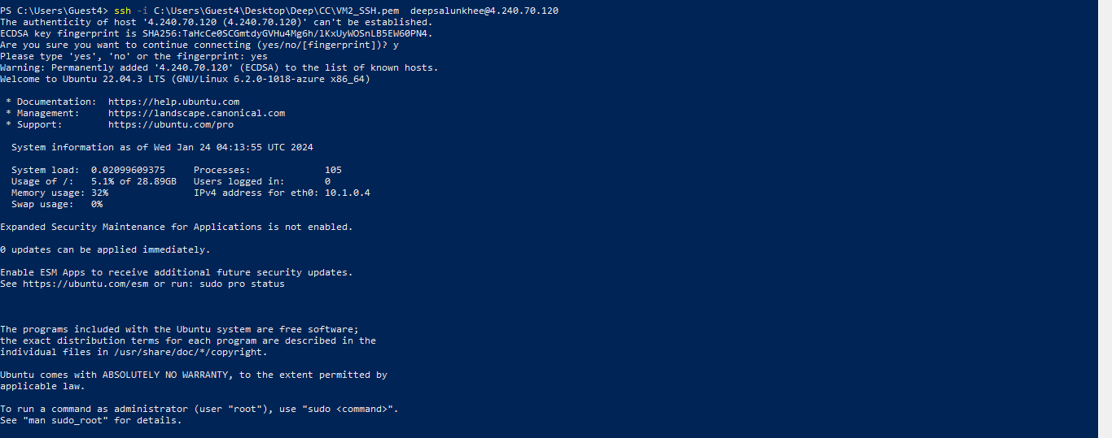

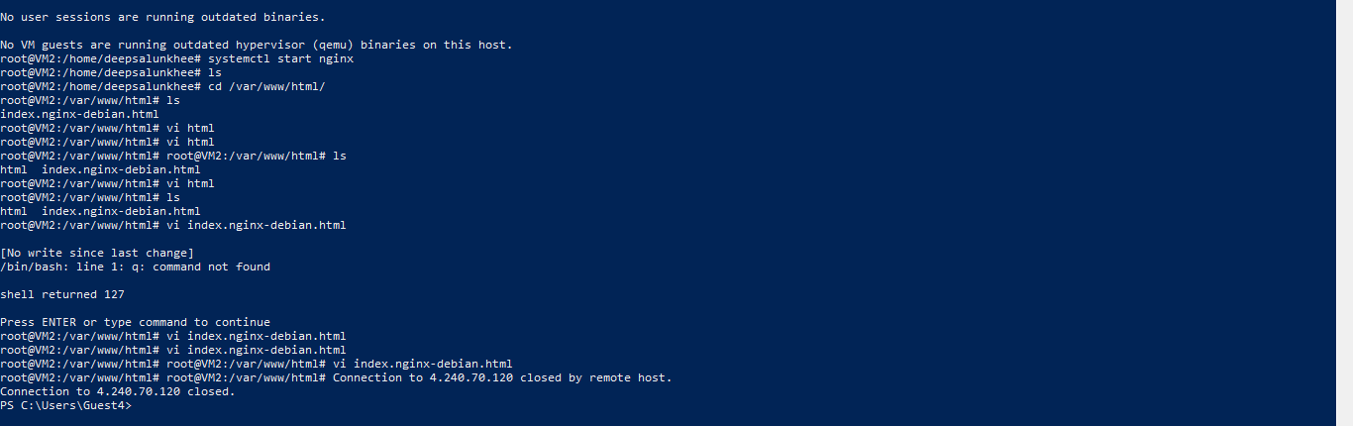

Scenario 2

1. Create a Windows VM ( Any Windows Server Machine) and connect using RDP
2. Install an IIS web server on this machine
3. Display the default web page of IIS server on public IP address of the machine
4. Change the default page content with your content to perform static website hosting

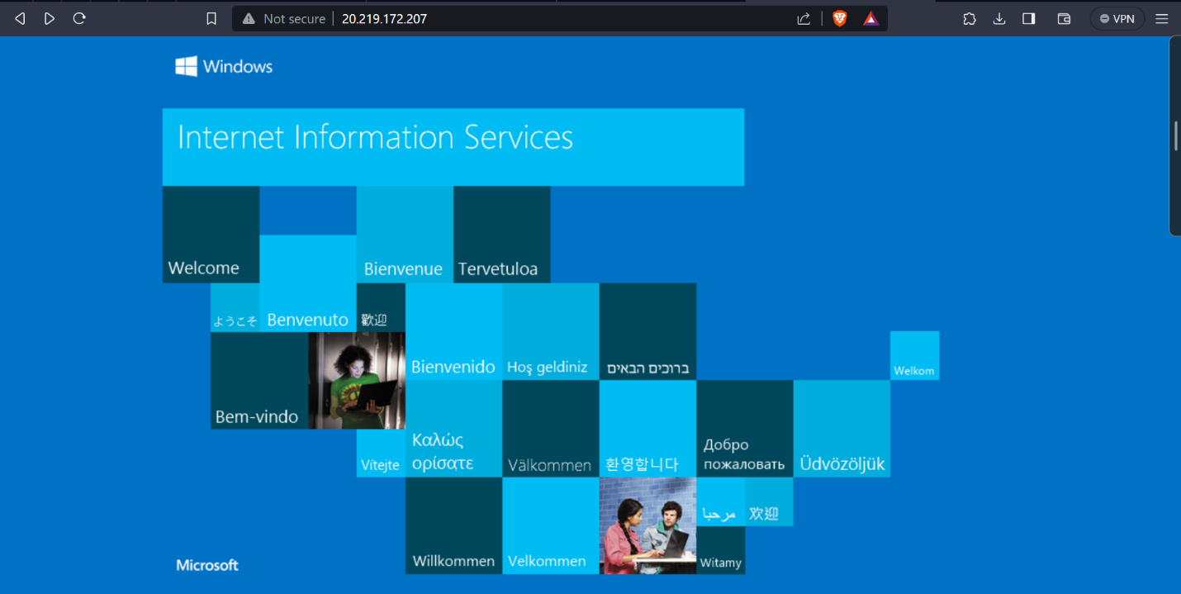

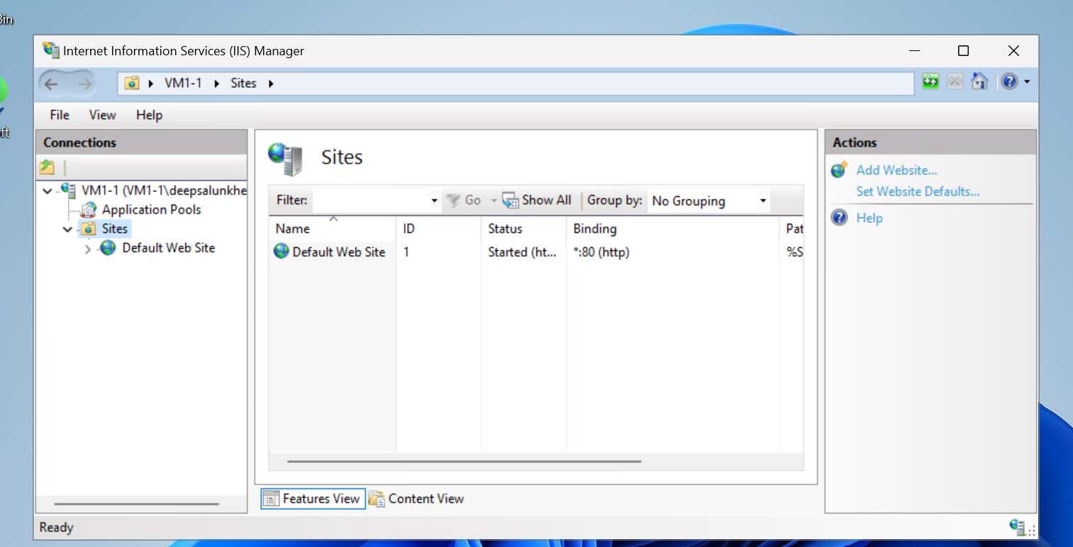

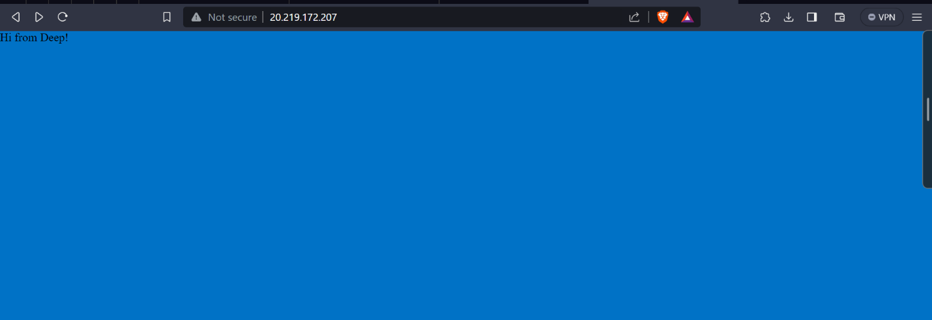

Scenario 3 and 4.

1. Same operations using EC2 service in AWS environment.

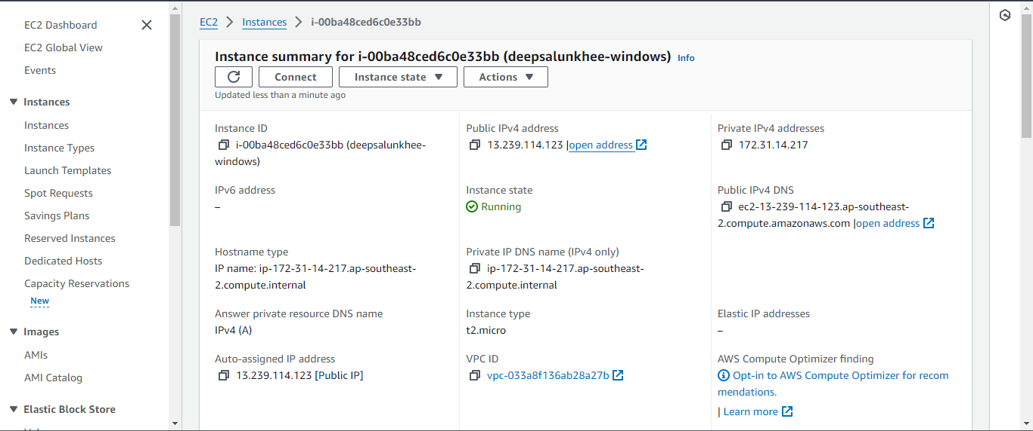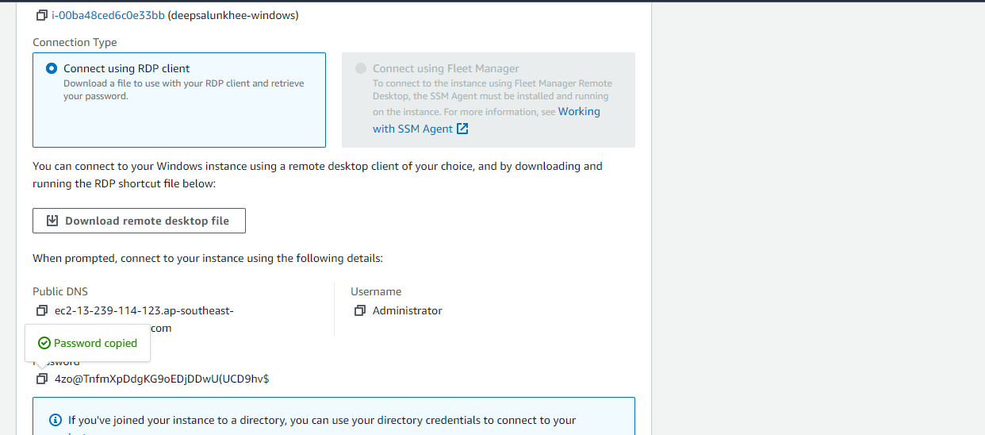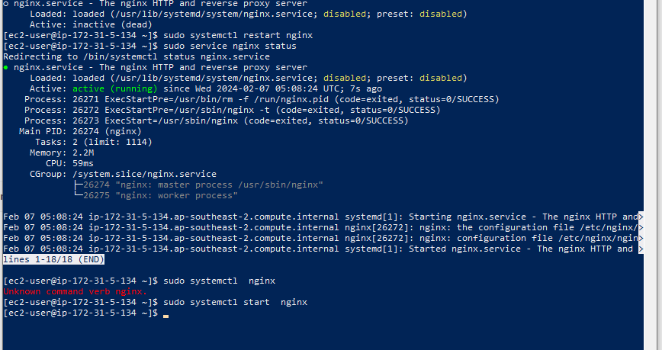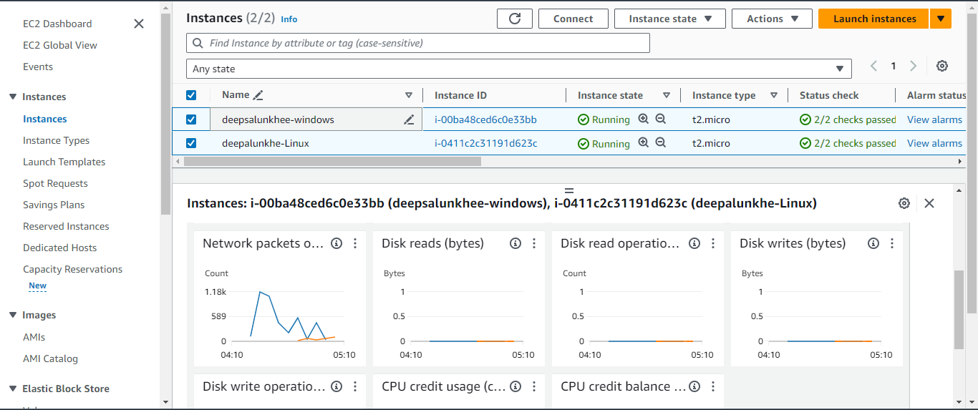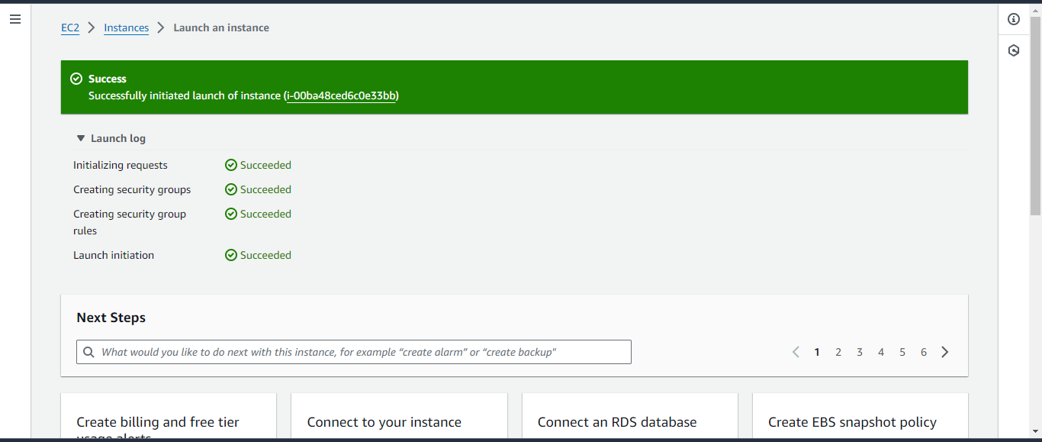



**Conclusion:**

**In conclusion, this lab involved the creation and configuration of virtual machines (VMs) on both Windows and Ubuntu operating systems to set up web servers and host static websites. The lab was divided into two scenarios:**

**Scenario 1:**

* **A Windows VM was created and accessed via Remote Desktop Protocol (RDP).**
* **Internet Information Services (IIS) web server was installed and configured on the Windows VM.**
* **The default web page of the IIS server was displayed using the public IP address of the VM.**
* **The default page content of the IIS server was modified to host a static website with custom content.**

**Scenario 2:**

* **An Ubuntu VM was created and accessed via Secure Shell (SSH).**
* **Nginx web server was installed and configured on the Ubuntu VM.**
* **The default web page of the Nginx server was displayed using the public IP address of the VM.**
* **The default page content of the Nginx server was modified to host a static website with custom content.**